

**Networking – No ICMP**

***Objective: In this lab you will develop a LKM called*** noicmp ***that will kill all incoming and outgoing ICMP Packets in the kernel. This will expose you to the net/ip header and give you greater control over the entire packet contents***

1. Complete the code below for netdead to kill network traffic on the host. Test your module by browsing to the internet while “pinging”. Unlink the previous lab, your TCP packets should get through! Log each time a packet is dropped.

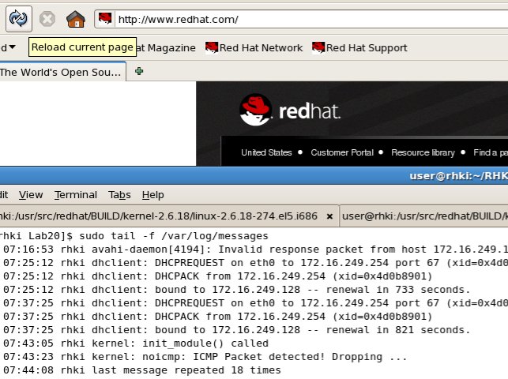

Steps:

* Examine the struct for sk_buff, iphdr, and icmphdr and filter out only ICMP
* Include the file net/ip.h for access to the ip header.
* The function skb_network_header() may be of help as well.